**Experiment No. 3**

**Name: Sumit Prabhakar Kamble.**

**Roll_no: 47**

**Div: B Batch: B2 Class: TY CSE**

**PRN: 21ST114282045**

**Title: Implement multi-valued attributes and inheritance in ORDBMS.**

**Problem statement:**

A. Implement multi-valued attributes in ORDBMS for a given dataset.

B. Implement inheritance in ORDBMS for a given dataset.

1. **Implement multi-valued attributes in ORDBMS for a given dataset.**

**Questions:**

**1. Create type name_ty with following attributes:**

* **Fname varchar**
* **Lname varchar**

create type name_ty as object

(

fname varchar(20),

lname varchar(20)

);

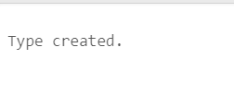

**2. Create type inv_ty with following attributes:**

* **Inv_no varchar**
* **Cust_id varchar**

create type inv_ty as object

(

inv_no varchar(20),

cust_id varchar(20)

);

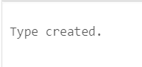

**3. Create table Customer with following attributes:**

* **Cust_id varchar**
* **Name name_ty**
* **Area varchar**
* **Ph_no integer**

create table customer

(

id varchar(20),

name name_ty,

area varchar(20),

phn_no int

);

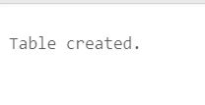

**4. Create table invoice using inv_ty.**

create table invoice of inv_ty;

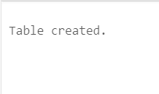

**5. Insert following data into customer table.**

|  |  |  |  |  |
| --- | --- | --- | --- | --- |
| **cust_id** | **name** | | **area** | **ph_no** |
| **fname** | **lname** |
| a01 | Sumit | Kamble | sa | 723622 |
| a02 | Shubham | Chougule | mo | 237842 |
| a03 | ravi | kumar | bi | 545621 |
| a04 | sunita | rai | ch | 983724 |
| a05 | james | smith | wa | 636472 |

insert into customer(id,name,area,phn_no) values ('a01',name_ty('Kamble','Sumit'),'sa',723671);

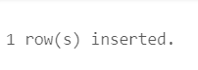

insert into customer(id,name,area,phn_no)values('a02',name_ty('Shubham','Chougule'),'mo',237842);

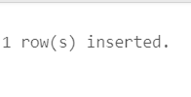

insert into customer(id,name,area,phn_no)values('a03',name_ty('ravi','kumar'),'bi',545621);

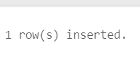

insert into customer(id,name,area,phn_no)values('a04',name_ty('sunita','rai'),'ch',983724);

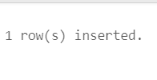

insert into customer(id,name,area,phn_no)values('a05',name_ty('james','smith'),'wa',636472);

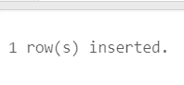

**6. Insert following data into invoice table.**

|  |  |
| --- | --- |
| **Inv_no** | **Cust_id** |
| i01 | a01 |
| i02 | a02 |
| i03 | a03 |
| i04 | a04 |
| i05 | a05 |

insert into invoice values ('i01','a01');

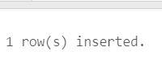

insert into invoice values ('i02','a02');

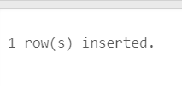

insert into invoice values ('i03','a03');



insert into invoice values ('i04','a04');



insert into invoice values ('i05','a05');



**7. Print both customer and invoice tables.**

select c.id,c.name.fname,c.name.lname,c.area,c.phn_no from customer c;

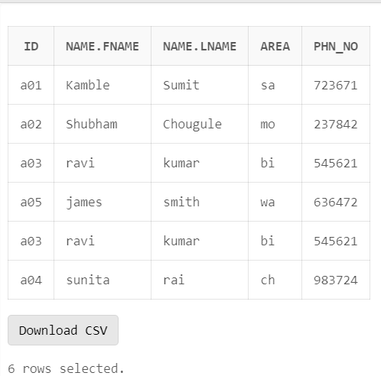

select * from invoice;

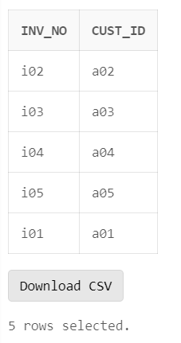

**8. Retrieve the list of first name and area for all the customers.**

select c.name.fname,c.id from customer c;

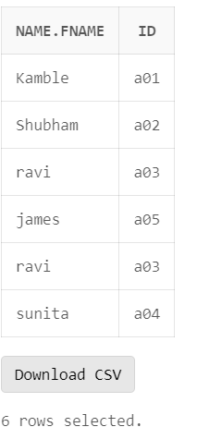

**9. Find the name of all the customers having ‘a’ as second letter in first name.**

select c.name.fname from customer c where c.name.fname like ‘_a%’;

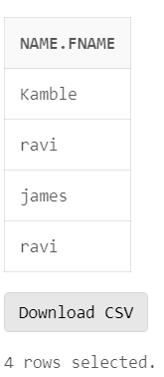

**10. Find the customers who stay in area sa or bi or ch.**

select area from customer where area=’sa’ or area= ‘bi’ or area= ‘ch’;

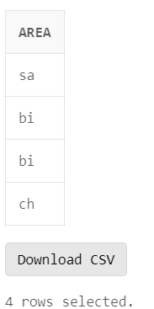

select area from customer where area IN(‘sa’,’bi’,’ch’);

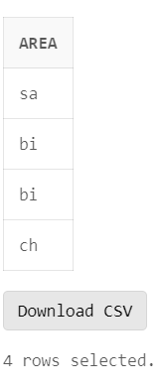

**11. Count the total number of customers.**

select COUNT(c.name) from customer c;

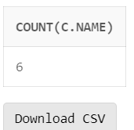

**12. Find the customer name and area with invoice no ‘i04’.**

select c.name.fname,c.name.lname ,c.area from customer c where id in

(

select cust_id from invoice where inv_no='i04'

);

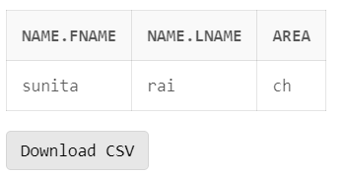

**13. Change the phone number of ravi to 546120.**

update customer set phn_no=546120 where id='a03';



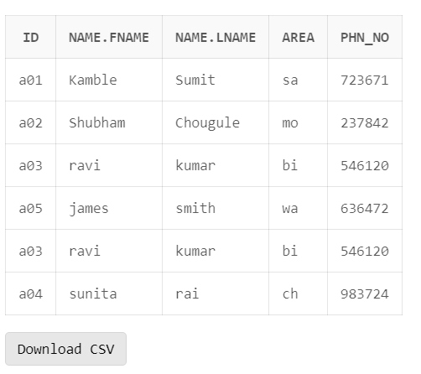

**14. Delete the record with invoice_no ‘i04’.**

delete from invoice i where i.inv_no='i04';

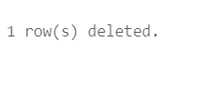

**15. Arrange the customer table in decreasing order of customer id.**

select c.id,c.name.fname,c.name.lname,c.area,c.phn_no from customer c

ORDER BY c.id DESC;

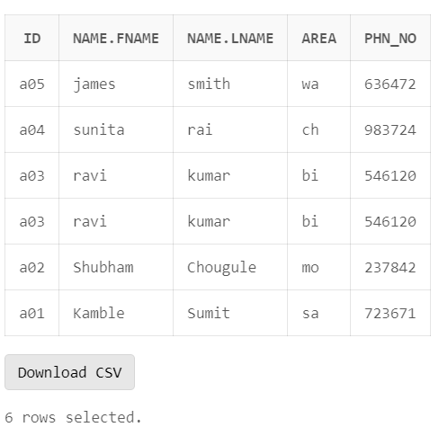

**16. Delete all the records from customer and invoice table.**

delete from customer;



delete from invoice;

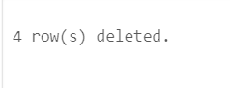

**B. Implement inheritance in ORDBMS for a given dataset.**

Questions:

1. **Create type name_ty with following attributes:**
   * + **Fname varchar**
     + **Lname varchar**

create type name_ty1 as OBJECT

(

fname varchar(20),lname varchar(20)

)not final;

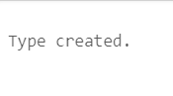

1. **Create type addr_ty with following attributes:**
   * + **City varchar**
     + **Pincode number**

create type addr_ty1 as OBJECT

(

city varchar(20),pincode number

)not final;

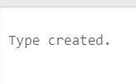

1. **Create type employee with following attributes:**
   * + **emp_id number**
     + **name name_ty**
     + **address addr_ty.**

create type employee as OBJECT

(

emp_id number,name name_ty1,address addr_ty1

)not final;



1. **Create type fulltime_emp under type employee with following attribute:**
   * + **Salary number**

create type fulltime_emp under employee

(

salary number

)not final;



1. **Create type parttime_emp under type employee with following attributes:**
   * + **Rate number**
     + **Hours number**

create type parttime_emp under employee

(

rate number,hours number

);



1. **Create table Fulltime of type fulltime_emp.**

create table fulltime of fulltime_emp;



1. **Create table Parttime of type parttime_emp.**

create table parttime of parttime_emp;



1. **Insert the following data to Fulltime table:**

|  |  |  |  |  |  |
| --- | --- | --- | --- | --- | --- |
| **emp_id** | **Name** | | **address** | | **salary** |
| **fanme** | **lname** | **city** | **pincode** |
| 1 | Rahul | Kumar | pune | 411234 | 50000 |
| 2 | Aniket | Sharma | Kolhapur | 410123 | 70000 |
| 3 | Abhi | Verma | Kolhapur | 410124 | 40000 |
| 4 | Rohan | Kumar | mumbai | 416605 | 60000 |

insert into fulltime values(1,name_ty('rahul','kumar'),addr_ty('pune',411234),50000);

insert into fulltime values(2,name_ty('aniket','sharma'),addr_ty('kop',410123),70000);

insert into fulltime values(3,name_ty('abhi','verma'),addr_ty('kop',410124),40000);

insert into fulltime values(4,name_ty('rohan','kumar'),addr_ty('mum',416605),60000);

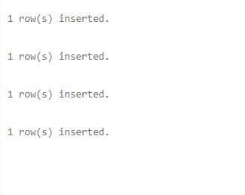

1. **Insert the following data to Parttime table:**

|  |  |  |  |  |  |  |
| --- | --- | --- | --- | --- | --- | --- |
| **emp_id** | **Name** | | **address** | | **rate** | **hours** |
| **fanme** | **lname** | **city** | **pincode** |
| 5 | Vibhuti | mitra | sangli | 410298 | 1000 | 8 |
| 6 | Ketaki | Bhave | Kolhapur | 410222 | 500 | 7 |
| 7 | Mahesh | Kumbhar | pune | 416289 | 2000 | 5 |
| 8 | Raj | Patil | pune | 409256 | 800 | 4 |

insert into parttime values(5,name_ty('vibhuti','mitra'),addr_ty('sangli',410298),1000,8);

insert into parttime values(6,name_ty('ketaki','bhave'),addr_ty('kop',410222),500,7);

insert into parttime values(7,name_ty('mahesh','kumbhar'), addr_ty('pune',416289),

2000,5);

insert into parttime values(8,name_ty('raj','patil'),addr_ty('pune',409256),800,4);



1. **Print the record of all Fulltime employees.**

select f.emp_id,f.name.fname,f.name.lname,f.address.city,f.address.pincode,f.salary from fulltime f;

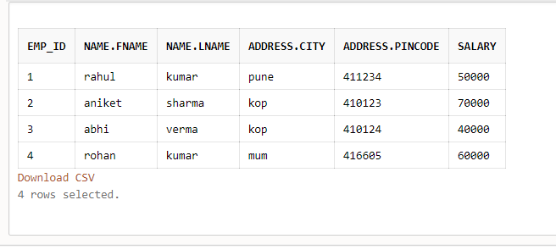

1. **Print the record of all Parttime employees.**

select p.emp_id,p.name.fname,p.name.lname,p.address.city,p.address.pincode,p.rate,p.hours from parttime p;

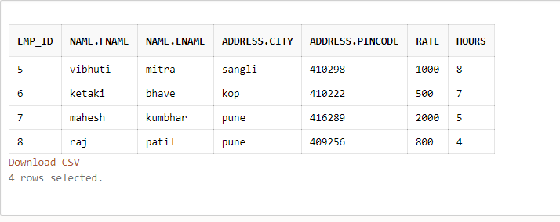

1. **Retrieve the record of all fulltime employees staying in Kolhapur.**

select f.emp_id from fulltime f where f.address.city='kop';

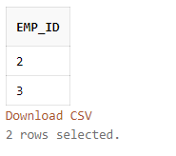

select f.emp_id,f.name.fname,f.name.lname,f.address.city,f.address.pincode,f.salary from fulltime f where f.address.city='kop';

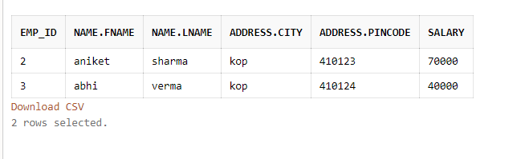

1. **Find all the employees whose rate is more than 500.**

select p.emp_id from parttime p where p.rate>500;

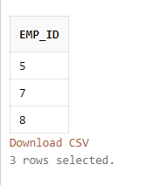  
select p.emp_id,p.name.fname,p.name.lname,p.address.city,p.address.pincode,p.rate,p.hours from parttime p where p.rate>500;

